Chess Board Modification Assignment

1. Left Offset Modification
I created a .left-offset CSS class with margin-left: 25px and added it to every row that started with a dark cell. I also increased the width of the chess board so the layout still fit correctly.
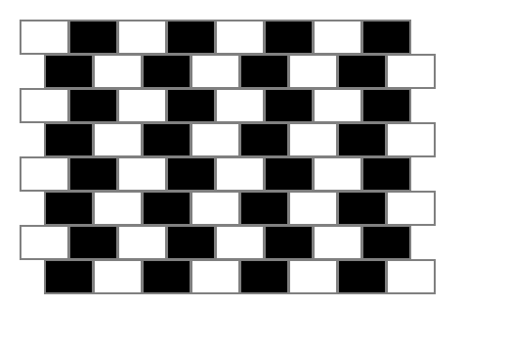
Observation: The board now looks staggered instead of perfectly aligned. The rows beginning with dark cells are shifted slightly to the right, creating a brick-like appearance.

2. Changing Dark Cells to Yellow
I changed the .dark background color from black to yellow.
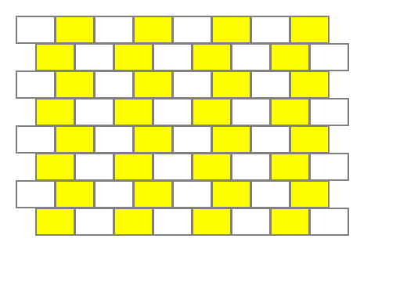
Observation: The board looks unusual because both light and dark colors are now bright. The contrast between the cells is reduced, which makes the pattern harder to recognize.

3. Red Color Replacement
I replaced the .light style with a red color and the .dark style with a dark red color from the video.

4. Half-Width Brick Pattern
I removed the .left-offset class and instead created a .half-width class with width: 25px. Half-width cells were added to the beginning and end of rows starting with dark cells.

5. Final Brick Wall Styling
I reduced the cell height, added rounded corners using border-radius, and increased the border thickness to make the board look more like a brick wall.
